Evangelize with Brotherly Love & Pres. Putin’s Anti Freedom of Religion Law
July 22, 2016
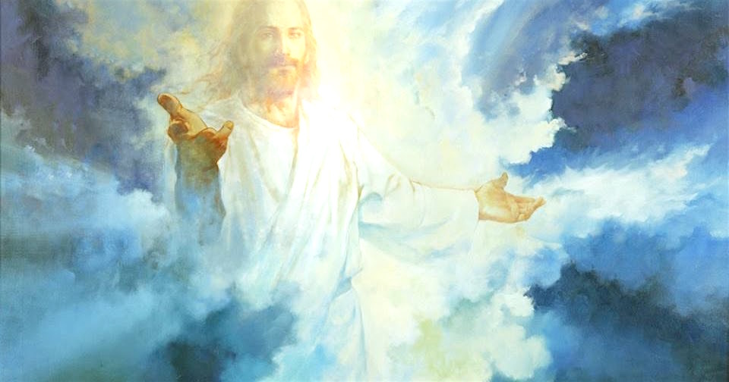
The Lord in His endless patience is with us, Heartdwellers.

Well, several people have now remarked on how President Putin signed into law restrictions on prayer and religion - serious restrictions - in his country just after I shared that I believe he was visited by a grace.

You know, it would be so nice if this world were so tidy and predictable. But in all my years with Jesus, nothing is ever tidy or black and white. There are many things which make no sense. For instance, why he would do such a thing, if God had softened his heart?

We have to understand that in Heaven, time is different than on Earth. That grace may have visited him then and he still signed a suppressive law. That may very well have been the Lord trying to touch his heart before he did it. There have been many times when I seriously doubted the Lord, because I didn’t understand the nature of spiritual things and how they work. So, it didn’t make sense to me.

Pres. Putin may have signed that law anyway, or perhaps the grace of a visitation fell at a different time than what I experienced. Or perhaps the Lord was ratifying one thing and not addressing the law at all. Just because God approves one thing in a person’s life, doesn’t mean He approves everything.

I sensed at that time what Jesus was approving was his position on nuclear war and how he was trying so very hard to avert that. I sense that he is under much pressure by the more communist-oriented faction of his country to use harder measures against the U.S., and perhaps even being severely opposed by them. And you know that presidents can get themselves assassinated by going against certain powerful groups…such as John F. Kennedy did.

So, signing this into law may have been the lesser of two evils. Who are we to say? But one thing I do believe with all my heart is that Pres. Putin was visited with a grace and God is on his side in the world political arena, and against the NWO.

Over the years, as I grew in discernment, I learned not to ‘react’ to apparent contradictions unless it was glaringly clear that what I received was a lie. Then I had to go back to discern what door I left open and try to understand what the Lord was saying to me.

So, in conclusion: Pres. Putin is against the NWO, he wants disclosure of the whole demon/alien agenda in the United States, he wants the people of America to know that our president is pushing him into a corner until he comes out with nuclear punches. He doesn’t want that war anymore than we do. And God IS on his side. He is opposing what is wrong and God is standing with him.

As far as signing the law goes, I personally don’t agree with it. I wouldn’t think that the Lord was for such a thing. However, I don’t know everything there is to know about his situation and Jesus so far has said nothing to me, so who am I to question? I do believe we should pray for Pres. Putin to rescind the law. But at least remember: part of the man is standing on God’s side and opposing the NWO and their advancing against the sovereignty of nations. The other part, like all of us, needs sanctification.

God the Father and Jesus have been grieving lately, Heartdwellers. Many of us have witnessed incredible sorrow and tears as I mentioned in my last message. So far He has not disclosed what is breaking His heart and all we can do is keep Him company and caress His aching heart with our adoration and praise. I do know that the end has been put off and we have many opportunities to set things right in our own hearts, with our relatives and those who need salvation. Now they'll have another chance to turn to God.

Jesus has set before me things to complete and my heart is very much comforted that we have more time. Many of you have begun your own web sites with beautiful art work and music, reaching out to the unsaved. This is your chance to go for it and spread the word far and wide while our Bridegroom is delayed. So, let’s not fall into anger or self-pity, let's make the best of it.

At this point I asked the Lord, 'Do you have something to say, Jesus?'

He began, "Indeed, My ways are higher than your ways, yet I impart understanding to the simple. It is true that I may approve a man in many ways and not approve him in others. But My heart is focused on avoiding world war right now and when President Putin disappeared for that space of time, he certainly was considering launching against America. Not for direct aggression from America, but for the under-handed things being done by our country to topple his neighboring governments that he had been working with. Syria was just the last straw, and that is why he swung into action.

"Your current president and all he represents has no intention of preserving this country. He is out to destroy everything about it. But I have withstood him and protected certain key elements to give you another chance at righteousness. It will certainly not last forever. But while it does please, My children, support what is right.

"During the reprieve I have given, many, many, many will be saved. That is why you have so much to do. You play a major role in the stability of this country not just through prayer but also through communication and the brotherly love you show the unsaved. I am counting on those that have been sent out to reach the Muslim population that is now floating around in Europe with no home. If you are called to this, it is a noble work and the fields are ripe for the harvest.

"One of the things you can do on this channel is disciple those who are new here. I am sending many young people who haven’t a clue about My ways or My love for them. They come here tossed about and torn, not knowing which way is up and they leave edified with more understanding and a budding relationship with Me.

"This is so important to Me, My people. Take good care of these poor lost ones. Be a friend to them, refer them to My teachings on this channel and lead them in the ways of righteousness. Be tender and gentle. Do not respond in legalisms; draw them to Me with love. Soon enough they will be hungry to live the way I want them to. This is one of the greatest mistakes those who evangelize make, especially now in this season.

"I am working in a way that is totally different from the previous century’s evangelists. The people of the Earth have been so downtrodden with judgment, they run like scared rabbits when they hear condemnation. They grew up with that. They live in a bubble of condemnation that continually haunts them with such thoughts as, 'You’re good for nothing! You’re a hopeless sinner going to hell, you’re not good enough for God. Who do you think you’re fooling? Don’t even try to go there, He doesn’t care about you.'

"These are the lies of the devils and this young generation has been handed that bitter pill by their parents - unless, of course, their parents are liberal and have no real morality. And anytime religion is broached, that is what their children hear from them."

In other words, the children hear downgrading remarks because the parents have had bad experiences in the past.

He continued, "And this attitude will scare them away, not draw them in."

Wow, Lord, I can relate to that. I ran from anything ‘Christian’ and so did Ezekiel because there was so much judgment and condemnation. Both of us were converted by the Lord’s love. Both of us came to Him because He first loved us. I felt His powerful love the night I was saved, and because I felt that pure, sweet love, I immediately recognized and confessed my sins.

I was in the New Age at the time, which doesn’t believe in sin. So for me to confess my sins without having any teaching about it was truly supernatural, and the work of Holy Spirit. It was the overwhelming love coming from God that I felt and responded to in repentance.

Jesus continued. “There are so many who truly want to do what is right. They want to live right but they are frightened by what they consider is the price tag. You know how it is: when something is so beautiful, you just have to have it, and you are willing to give up many other things just to obtain it. The 'it' is Me and a relationship with Me. Not beginning in perfection, but beginning right where the soul is at and moving into perfection without a condemnatory word or attitude goading and pushing them. Rather, coming from a place of love, understanding and forgiveness.

"Love hits the mark in their wounded hearts and they respond by giving up those things that they know are not pleasing to Me. The other way around, the legalistic way - giving up things without the motivation of Love - may work for a short time on the surface. But deep down inside, the soul is struggling and ultimately resents being restrained from their familiar pleasures. Then they want out of religion altogether. That's when they are soured on Me and I have a huge barrier to overcome to win them back. This is Satan’s doing.

"It is your love for Me, My People, that causes you to break with sin. Yes, some of you are afraid of punishment, but for the most part our relationship is about love, not condemnation forcing you to live a lifestyle that the religious community approves of.

“That is why I want this channel to be a place of unconditional love. Where a newcomer can feel welcome and see that you all struggle with the same issues, but somehow God is still affectionately with you in spite of it. This is the strongest possible witness to My Love.
"There are souls who do need to hear the message straight up in order to wake up. But they are not the fatally wounded. They are the strong, rebellious children of the world that are looking for boundaries that make sense and last throughout time…not fads. And I have My vessels unto honor who preach that, as well. Different souls respond differently, and I have made a provision for all.

"But on this channel, we welcome in the lame, the sick, the broken and treat them with the utmost respect and genuine affection. Oh, how blessed I am to have a group such as this tending to the outcasts! Great is your reward in Heaven.

"So now I have again encouraged you to move forward and reach out while there is yet time. Reach out in love. Brotherly love. Unconditional love that is right on the very same level with those just beginning their journey with Me.

"I am with you, Dear Ones. I am SO with you, in your every effort. Remember, when a grace does not land on the one you intended it for, I see to it that it lands on one who is ready to accept it. So, you are never wasting your time if someone turns away. That prayer, that grace, that time spent will not return to Me void. It shall accomplish what it was released to do.

'Be encouraged My precious ones, be encouraged. I will make your remaining time here exciting and full of the abundant life of My Kingdom if you put forth your very best effort. Truly I am with you."

